* Open the WormSizer script using Matlab

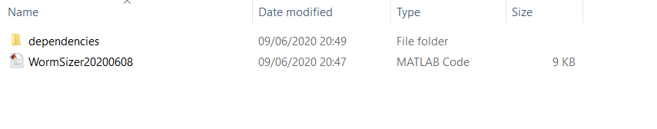

* Add the dependencies folder to Matlab’s path (right mouse click on dependencies folder in ‘Current Folder’ – Add to Path – Selected Folders and Subfolders

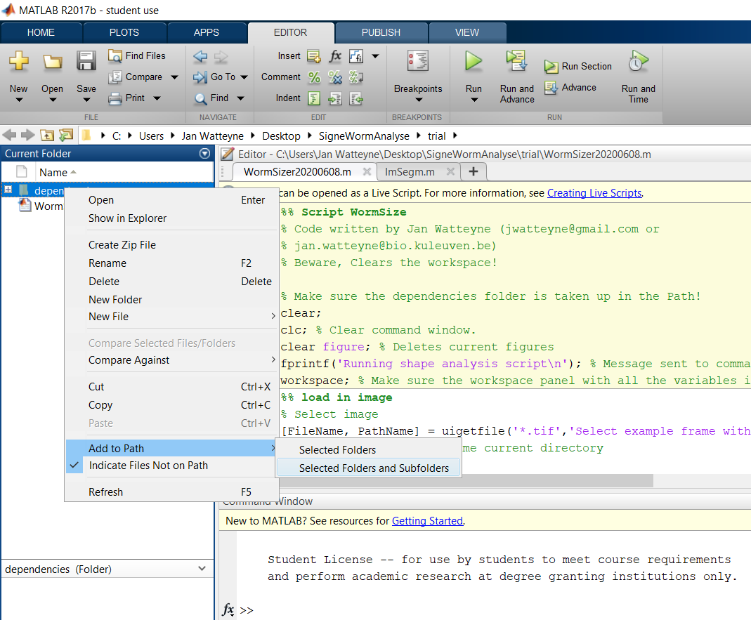

* Run the entire script by pressing the big Play button

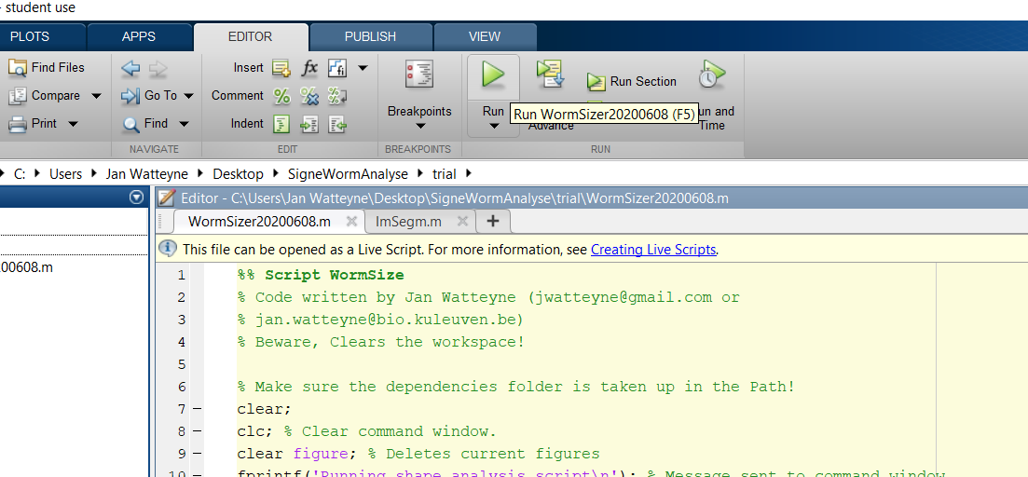

* The user is pushed to select an image (.tif) in the folder you want to analyze (bundle multiple images from the same condition into one folder, fi all N2s together)

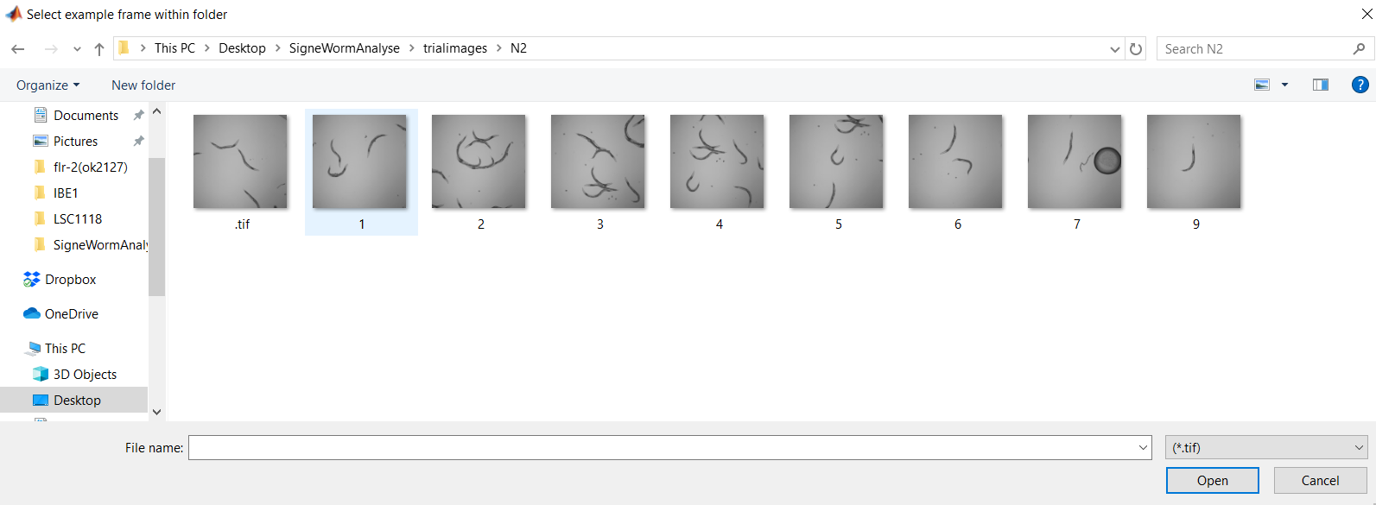

* Next, fill the name for that condition (fi. N2) and the calibration factor (pixel/um)

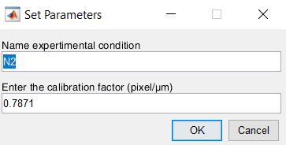

* Within the same folder as you already selected one image, select the image on which you want to fine-tune the worm identification (best to select one with a combination of individual animals, isolated eggs, and animals touching)

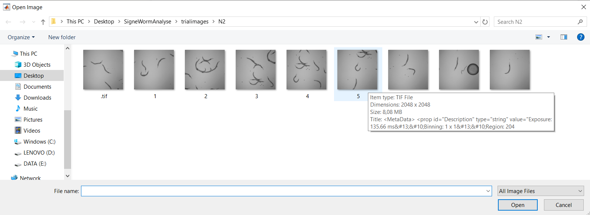

* A graphical user interface pops up, which allows you to fine-tune the worm identification settings using sliders. The default settings work well for various illumination conditions. Pay close attention that only worm objects are highlighted and set the ‘lower size threshold’ so that isolated eggs are not included. Don’t worry about weird artefacts or eggs touching the worms, you can remove those manually in the next step. Click reset to go back to default settings. If everything is fine, press OK.

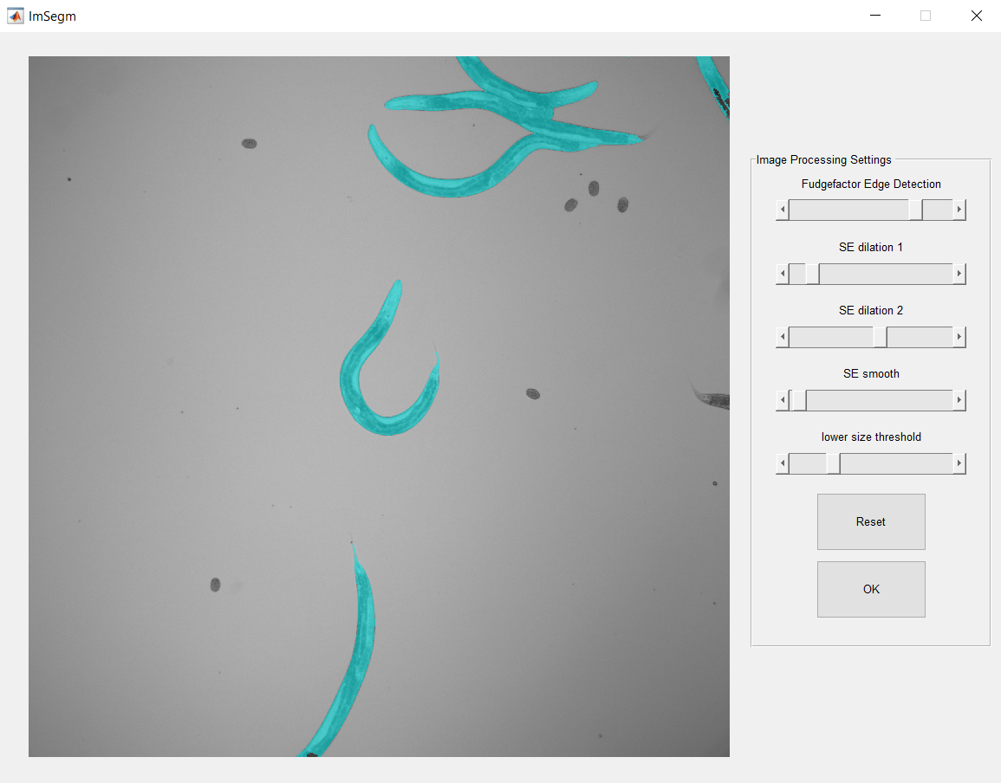

* For each image, you will then get to manually trace artefacts on the pictures. You can use the zoom IN-OUT function to help you with this. Trace the contour of big artefacts, or manually remove eggs/worms touching other worms. When finished, click to review your edit

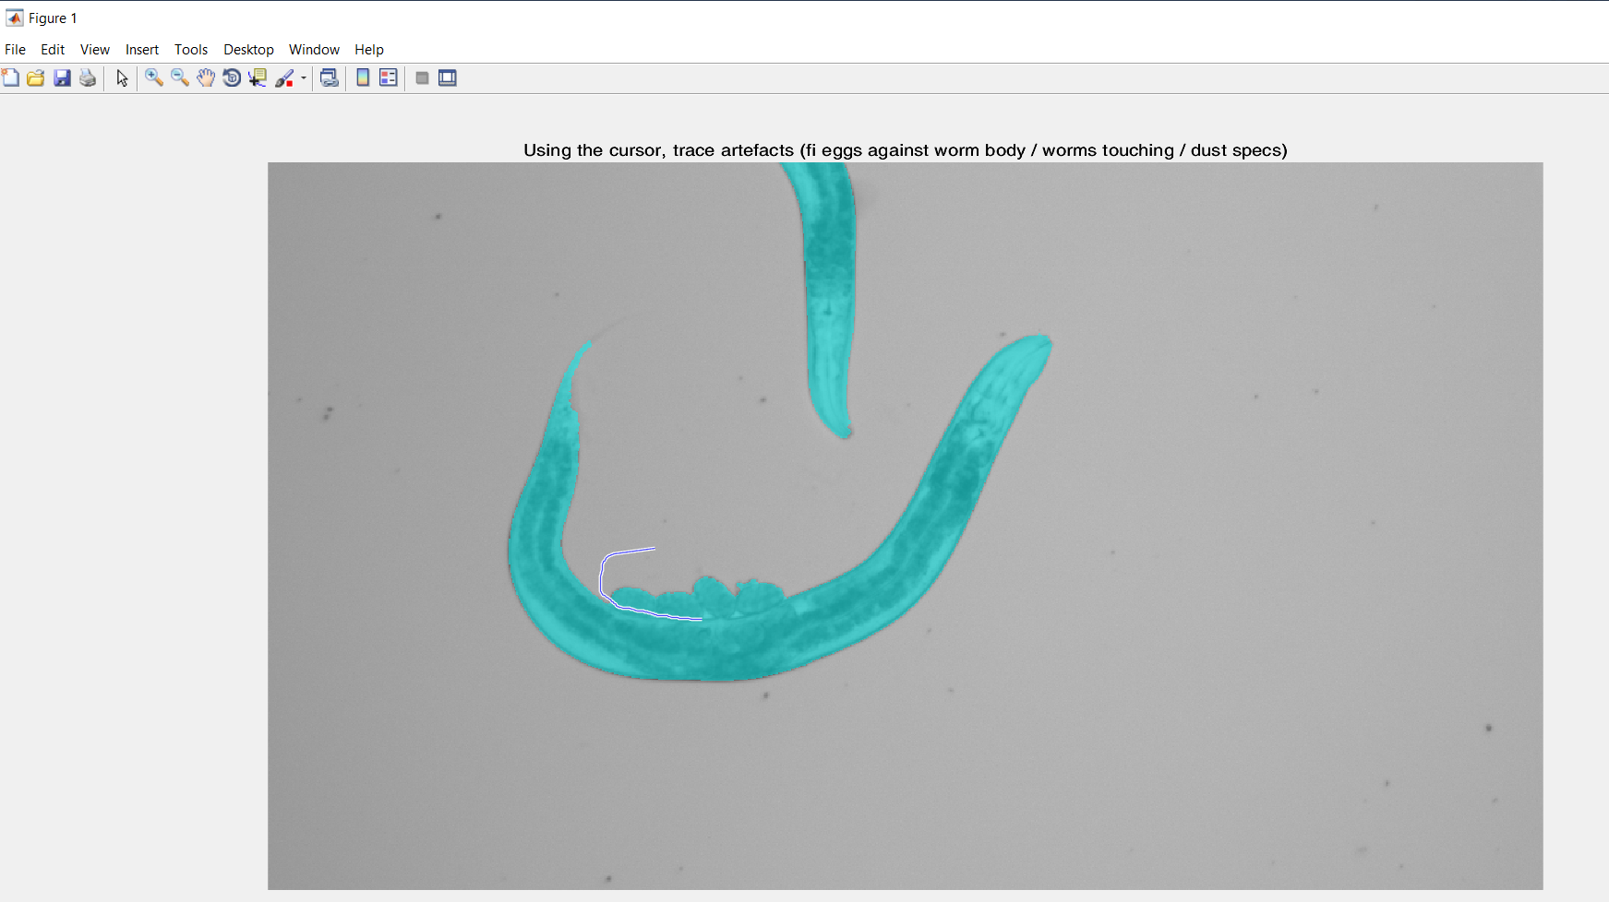

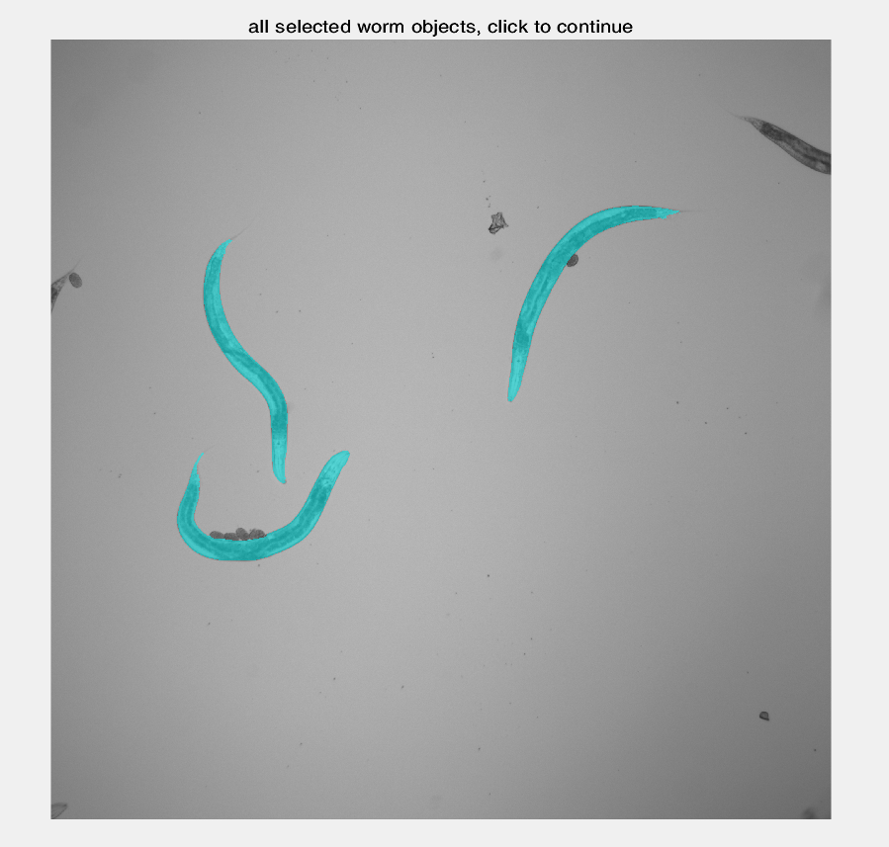

* Next, the script will automatically compute the skeleton for each identified worm object, and automatically draw the results in both a .jpeg (‘Name’ – Skeletons.jpg for manual review of the image processing) and an Excel holding all the data for the entire folder (SaveName – Data.xlsx).

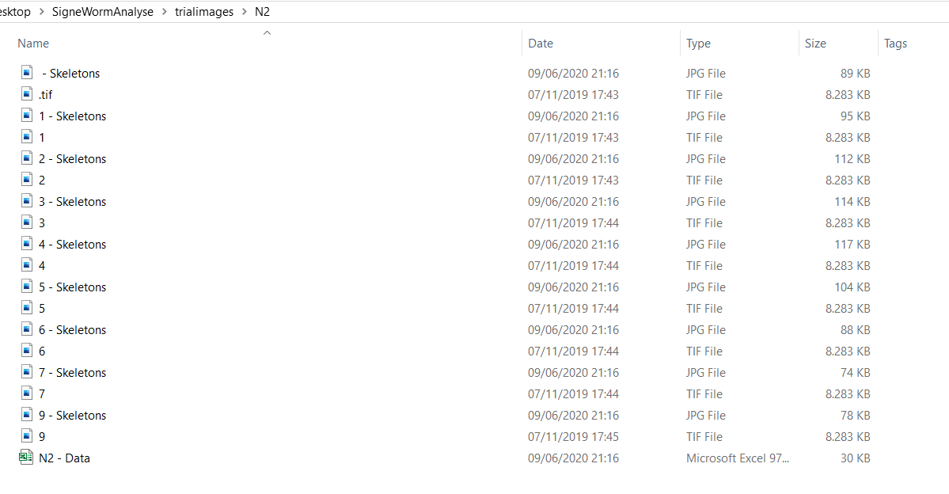

* Use the .jpg pictures to identify which segmentations are not successful (this can be due to non-optimal image segmentation settings, or weird artefacts). These can then be removed from the SaveName – Data.xlsx. The blue line is the contour (it’s normal to have a small gap, which is due to the algorithm used to smoothen the contour). The red line is the worm ‘spine’, from which the length is computed. The skeleton lines are used to compute the worm volume.

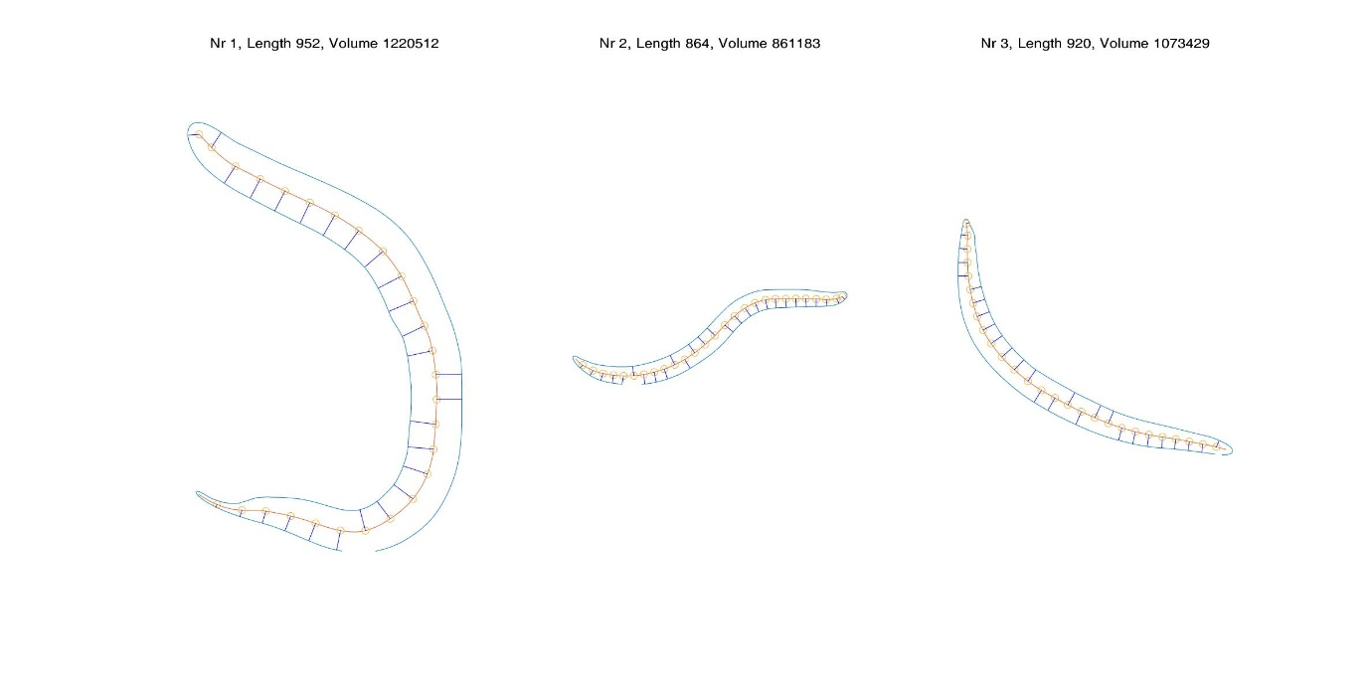

* SaveName – Data.xlsx: Experiment column shows the name of the image for which the worms are analyzed. Worm Nr corresponds to the Nr in the ‘Name’-Skeletons.jpg. Worm area is figured in both number of pixels and µm², as are skeleton length (length of the red line), MiddleWidth (mean ‘width’ of the worm in the middle, corresponding to the mean width at the 8 most central branches of the skeleton) and Worm volume (approximate volume for the entire worm when assuming worm widths in the x-y plane are also the same in the z plane).

